WEEK-2 SKILL

- To Install Linux VM, Configure GCC, Setup Git Repository, Create Project Structure, Understand Shell Architecture, Build Initial Makefile.
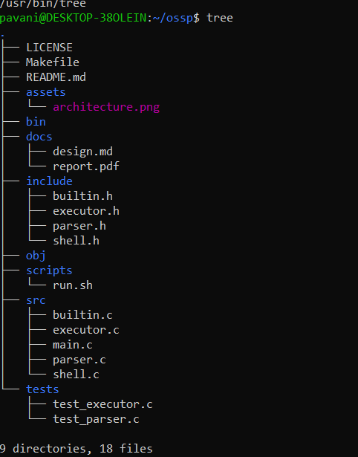

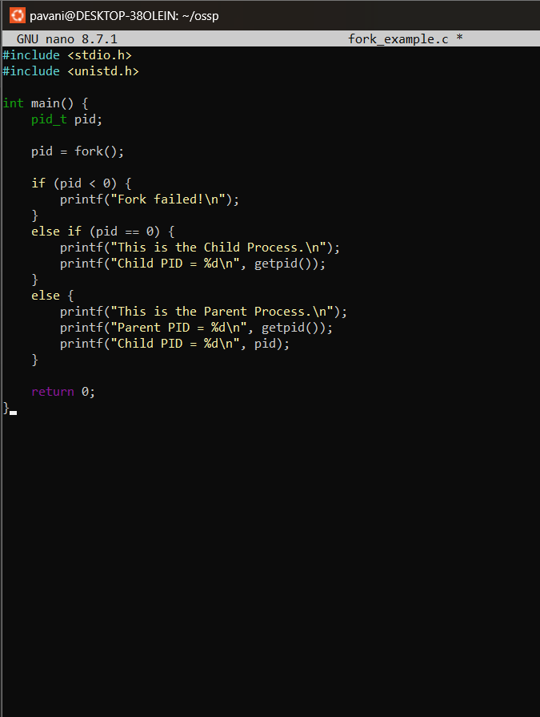
OUTPUT: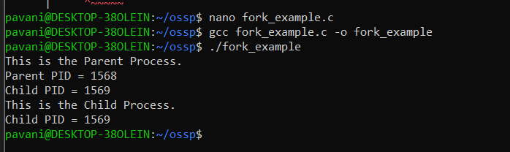
REPORT: I successfully installed the Linux environment and configured the GCC compiler. I created a Git repository and organized the required project folders and files. I also understood the basic shell architecture and created a simple Make file to build the project.

- To Analyze process abstraction, execute fork(), understand exec() family, analyze parent-child relationships, inspect process tree, practice system call tracing.

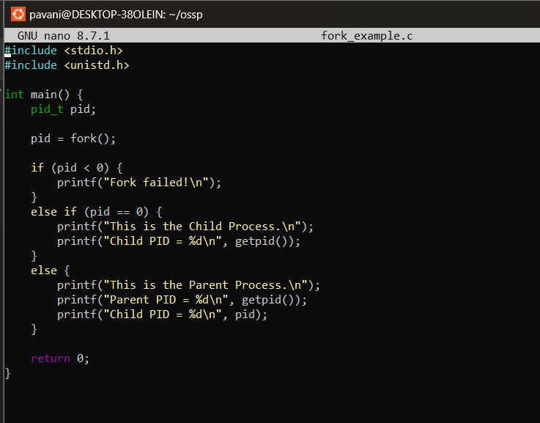

OUTPUT:
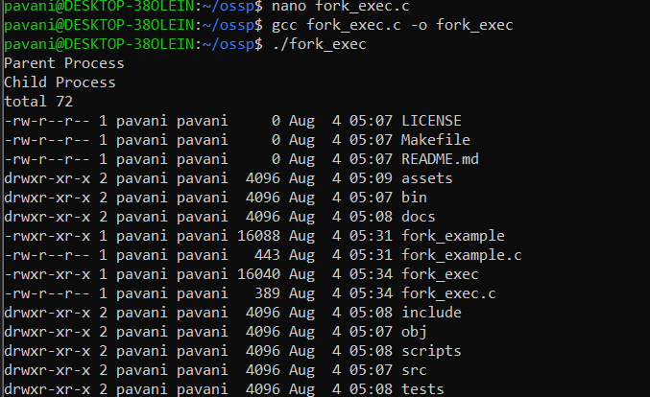
REPORT: I executed the fork() program and observed how a parent process creates a child process. I understood the working of the exec() family and learned how processes are replaced during execution. I also examined the process tree and practiced tracing system calls to understand how a program interacts with the operating system.

